DATA 430 Technical Report  Assignment 2: Bayesian Classification | Russell Larkin
Predicting COVID-19 with Bayesian Classification
URL to dataset: https://www.kaggle.com/datasets/hemanthhari/symptoms-and-covid-presence?resource=download
This template should be used in conjunction with the assignment instructions. The size of the text area below will expand to the length of your response; the area should not be interpreted as a required or suggested length of response. Responses within the text area should be single spaced with Times New Roman 12pt font. The body of the document will likely be 6-9 pages, not including the Appendix; length may vary depending on specifics of the analysis and the dataset. As needed, APA format in-text citations should be included, along with a full references list at the end of the document.
Overview
Problem Domain: give some background and context about the problem domain (application area). For instance, if you are doing the analysis for predicting heart disease, provide some context about the disease and include some interesting statistics about it. Also, discuss how the method is relevant for the chosen problem.
COVID-19 emerged in late 2019 as a highly transmissible respiratory illness caused by the SARS-CoV-2 virus, with symptoms that could feel much like a cold, flu, or pneumonia. By June 1, 2024, the World Health Organization reported over 600 million confirmed cases and 1.2 million recorded deaths worldwide, with hospitals repeatedly strained during successive waves of infection (CDC, 2025). Asymptomatic and pre-symptomatic transmission, combined with variable sensitivity of PCR testing (including false negatives up to 30%), complicated timely diagnosis and containment.
My goal is to predict a binary outcome: whether a patient will test positive or negative for COVID-19. This will be based on self-reported symptoms, exposure, and prior medical conditions. Bayesian classification is relevant and natural choice, because it explicitly models the uncertainty in predictions and naturally incorporates prior knowledge about class probabilities. This is critical when working with real-world health data that may be incomplete, noisy, or imbalanced.
There are three main types of Naive Bayes qualifiers: Bernoulli, Multinomial, and Gaussian. The differences between these types is the assumptions they make about the distribution of features. I started with Gaussian, but ultimately chose Bernoulli Naive Bayes (BernoulliNB) for this project because it is best suited for binary/boolean features. It assumes each feature is a binary-valued (0/1) variable.

Objective: clearly state the objective of the analysis in relation to the kind of algorithm you are employing. Use specific language as to what question(s) you are trying to answer using the specific analysis/modeling type.
My primary research question is:
“Will a public health screening questionnaire – utilizing a combination of symptoms, exposure risk factors, and reported pre-existing conditions – be able to effectively discriminate COVID-19 positives from negatives cases, with an emphasis on zeroizing false negatives?”
My goal will be to develop a BernoulliNB model that predicts whether an individual will test positive for COVID-19 (binary target) from self-reported symptoms, exposure risk factors, and pre-existing conditions. BernoulliNB is best suited for this because it assumes each feature is a binary-valued (0/1) variable.
I will (1) quantify feature distributions and relationships in an exploratory analysis, (2) engineer summary scores for symptom and exposure intensity, (3) tune laplace/additive smoothing (ɑ) to keep rare terms from getting zero probability, and (4) evaluate predictive performance via accuracy, precision/recall, F1, confusion matrix, and cross-validation.

Analysis
Exploratory Analysis: describe the data including the source, the collection method, and variables. Perform exploratory analysis. Also, select few key variables (including the target variable for supervised learning) and study their distributions using plots such as histograms, box plot, bar chart, etc.
Data source and collection method: I used a publicly available Kaggle dataset (H. Harikrishnan, 2020) of 5,434 individuals. Data included my target variable (COVID-19) and 18 binary features (after dropping two constant columns that added no value: Wearing Masks, Sanitization). I checked to make sure there was no missing data, null values, outliers, or invalid data types. The collection method seems to be a questionnaire. Features include eight symptom indicators, five exposure indicators, and five pre-existing conditions. The target “COVID-19” has four times as many positives (n = 4,383) as negatives (n = 1,051).
I created a heat map to explore the target against the features. The heatmap revealed that ‘Abroad travel’, ‘Attended Large Gathering’, and ‘Contact with COVID Patient’ were the highest exposure risk factors, and ‘Breathing Problem’, ‘Fever’, ‘Dry Cough’, and ‘Sore throat’ were the highest symptoms factors. I also computed pairwise correlations among all predictors (not just target vs. feature) and confirmed that no two features exceeded r|≈0.8. In doing so, the model is guarded against the variance‐inflation and coefficient‐instability issues that come with extreme multicollinearity.

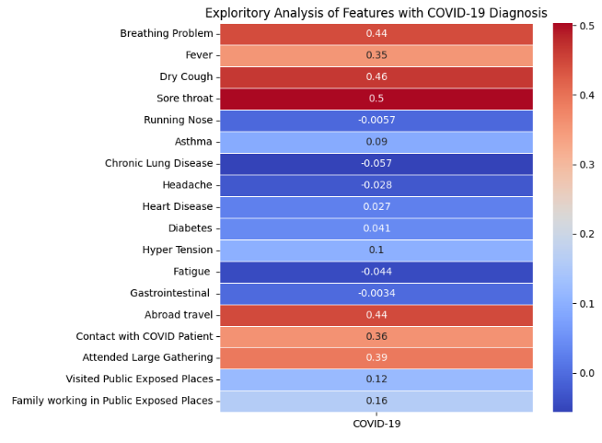Figure 1: Target correlation heatmap.

Symptom_Score (sum of breathing difficulty, fever, dry cough, sore throat) ranges 0–4 and shows most of our subjects cluster toward the high end of the symptom scale (~2000 with 3-4 symptoms). This corroborates the heat map by proving symptoms are a high predictor of COVID, and very few people were asymptomatic.

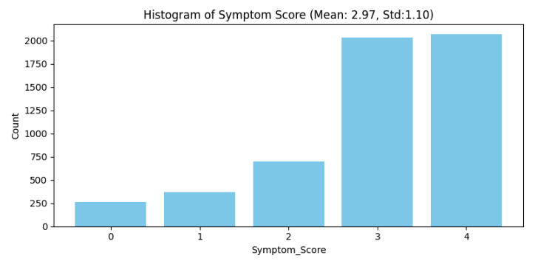
Figure 2: Histogram of Symptom_Score.

Exposure Score (sum of abroad travel, large gathering, contact with known case) boxplot shows that the distributions barely overlap. Negative COVID diagnosis without exposure is almost always ‘No, and positives results had usually two or three exposure events. That clear separation justifies exposure events as a key predictor in our model.

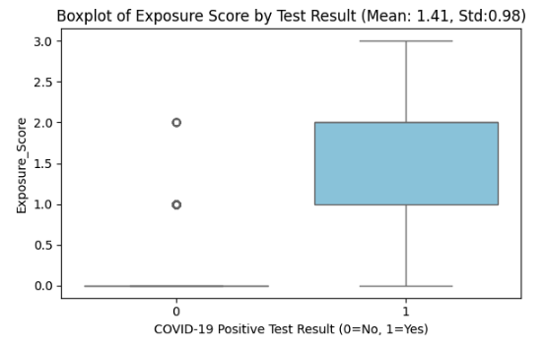
Figure 3: Boxplot of Exposure_Score by COVID diagnosis.

Preprocessing: armed with the exploratory analysis, perform the necessary preprocessing, both general and specific types appropriate for the modeling type being employed.
What I changed immediately:
- Removed two features that had only one unique value: ‘Wearing Masks’, and ‘Sanitization from Market’ for zero variance. These provided no information gain to the model.
- All yes and no values were converted to binary.
I created additional features:
- ‘Symptom_Score’ – the sum of the top symptoms risks (breathing problem, fever, dry cough, sore throat).
- ‘Exposure_Score’ – the sum of the top exposure risks (Abroad travel, Contact with COVID Patient, Attended Large Gathering)
I also explored removing some low-impact features (eg pre-existing conditions), but found that retaining the features yielded the best results.

Model Fitting: explain the key steps and activities you perform to fit the model. Experiment (as appropriate) with parameters tuning. This is key, what separates highly accurate model from a less accurate ones is the amount of performance tuning performed.
All code can be found in my Google Colab Notebook:
RLarkin Google Colab - COVID-19_Asgn2

Initial model fitting involved:
- Splitting the dataset into 80/20, train/test.
- Using sklearn ‘naive_bayes’ with ‘BernoulliNB’ classifier.

The model was initially trained using default parameters, then refined by:
- Adjusting the standard threshold manually, and ultimately settling with 0.5.

I attempted to adjust smoothing parameters of the fixed Laplace (ɑ=1) to find the level that best balances zero-probability prevention. Adjustments had little if any effect on my primary 100% recall focus.

Results
Model Properties: explain the components of the fitted model and their characteristics. Leverage functions to summarize the model properties. Also, leverage visualization as required.
Bernoulli Naive Bayes keeps two main pieces of information: how often each class shows up in the data (the priors) and, for every yes/no feature, how likely that feature is to appear when a case is positive versus negative. To make a prediction it just multiplies those stored chances together—adding a tiny “smoothing” value so nothing ever ends up as zero—and then picks the class with the bigger score. Because it only does counting and multiplying, the model is lightning-fast and easy to read, but it can miss subtle links between symptoms if several of them always show up together.
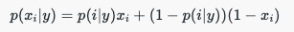
The Bernoulli distribution is used for discrete probability calculations. It either calculates success of failure.
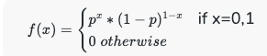
Output Interpretation: explain the result and interpret the final model output using terms that reflect the application area and in relation to the stated objective. This is where you check whether or not the stated objective is met.
The model successfully met its objective to predict whether a patient tests positive or negative for COVID-19 based on reported symptoms, exposure, and pre-existing conditions. The most predictive features were well-aligned with public health knowledge regarding symptoms and exposure events. Moreover, engineered features like Symptom_Count and Exposure_Score provided interpretability and allowed the model to generalize patterns across related variables.
The BernoulliNB output indicated high confidence in the positive class. The model predicted 0 false negatives, a critical factor in a public health screening tool during a global pandemic.

Evaluation: employ appropriate metrics to quantitatively evaluate the performance of the fitted model. For supervised classification, this includes simple accuracy, precision & recall (or sensitivity & specificity), all of which can be generated from a confusion matrix, or ROC.
Model performance was evaluated using multiple classification metrics. Results with:
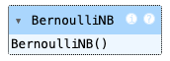
Accuracy: 96%
Precision (COVID+): 96%
Recall (COVID+): 100%
F1 Score (COVID+): 98%
Log Loss: 0.0916

I used Bernoulli NB because it reliably handles a binary dataset. The model achieved a mean recall of 94%, with scores ranging from approximately 0.86 to 0.99 across the folds. This reflected sensitivity to data splits and confirmed that the model consistently maintains strong recall.
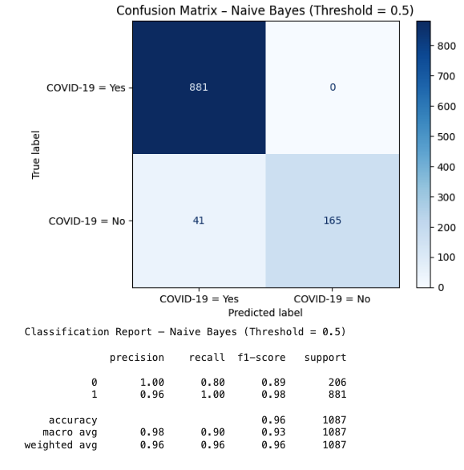

Figure 4: Confusion matrix and Classification Report

I believe this level of recall is required for screening purposes during a pandemic where missing a positive case would be more serious than a false alarm. In addition, the log loss (0.0916) indicated well-calibrated predicted probabilities. Feature importance and visualizations further support the model.

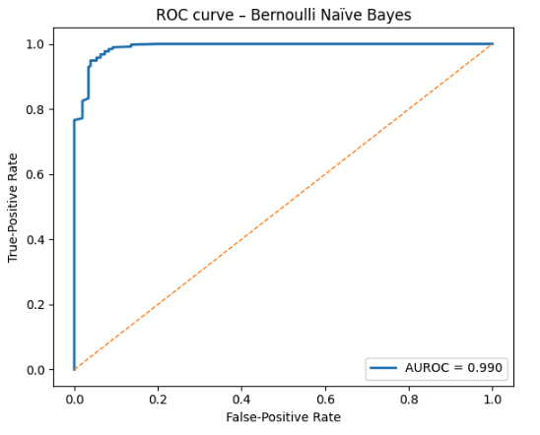
Figure 5: ROC curve.
The ROC curve charts the model’s true-positive rate against its false-positive rate over every possible probability threshold, with the diagonal line marking random chance. Because the blue curve hugs the left border and the top edge, the classifier reaches very high recall while keeping false alarms low across most thresholds. The area under the curve is 0.990, meaning there is a 99% chance the model will score a random chosen COVID-positive case higher than a negative one. That steep rise and near-perfect AUROC shows the model separates the two classes extremely well.

Conclusion
Summary: highlight the main findings in relation to the stated objective. You don’t need to discuss the details of the analysis and the model such as accuracy here, just focus on the key findings.
The BernoulliNB model achieved 96% accuracy, with 100% recall and 96% precision on COVID positive cases, leading to an F1 score of 98%. These results suggest the model is highly suitable for COVID-19 screening where recall is the top priority.
The key predictors were as expected: symptoms and exposure. This closely reflects historically known risk factors. Feature engineering of these known factors improved performance.
I was surprised that removing the pre-existing conditions reduced the accuracy of the model. I assumed this would have had an effect on the amount of deaths, but not the number of diagnoses of COVID-19. Testing the model by adding, removing, and engineering features was essential.

Limitations & Improvement areas: discuss the limitations of the analysis and identify potential improvement areas for future work. This could be related to the data, algorithm, or a combination of the two.
I believe the models limitations were as follows:
- BernoulliNB treats each symptom or exposure flag as if it were independent of every other. In reality, many symptoms co-occur (ie fever and dry cough) and exposures overlap, so this assumption can lead to misestimated probabilities. Additionally intensity of symptoms and duration of exposure could help distinguish borderline cases.
- Every feature contributes multiplicatively to the likelihood, even if some are weak or redundant. Rare but highly predictive features can be “washed out” if many weak features are present.

Future improvements could include:
- Incorporating more/new data for broader generalizations. Moving beyond simple yes/no flags (ie incorporating severity ratings or time since symptom onset) could give the model more granular information.

The model predicted a higher number of patients as COVID-positive who were actually negative. These individuals would have been quarantined as a precaution to prevent potential spread. While this results in more false positives, it aligns with public health priorities by minimizing the risk of missed infections. Overall, I believe this was a highly effective and well-performing model.

Appendix
My Google Colab Notebook contains all code and outputs.
RLarkin Google Colab - COVID-19_Asgn2


Figure 1: Target correlation heatmap.

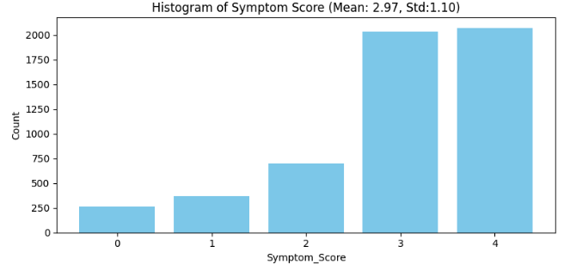
Figure 2: Histogram of Symptom_Score.

Figure 3: Boxplot of Exposure_Score by COVID status.


Figure 4: Confusion Matrix and Classification Report

References

Hemanth Harikrishnan. (2020). Symptoms and COVID Presence (May 2020 data). Kaggle.com. https://www.kaggle.com/datasets/hemanthhari/symptoms-and-covid-presence?resource=download

CDC. (2025, March 19). About COVID-19. COVID-19. https://www.cdc.gov/covid/about/index.html#:~:text=COVID%2D19%20most%20often%20causes,some%20people%20become%20severely%20ill.

Samy Baladram. (2024, August 24). Bernoulli Naive Bayes, Explained: A Visual Guide with Code Examples for Beginners | Towards Data Science. Towards Data Science. https://towardsdatascience.com/bernoulli-naive-bayes-explained-a-visual-guide-with-code-examples-for-beginners-aec39771ddd6/#:~:text=Bernoulli%20NB%20assumes%20binary%20data,each%20feature%20is%20binary-valued.

GeeksforGeeks. (2017, March 3). Naive Bayes Classifiers. GeeksforGeeks. https://www.geeksforgeeks.org/naive-bayes-classifiers/

GeeksforGeeks. (2023, October 25). Bernoulli Naive Bayes. GeeksforGeeks. https://www.geeksforgeeks.org/bernoulli-naive-bayes/

Overview and Objective — Level: L5
You present a clear, data-driven overview of the COVID-19 problem domain and establish a compelling rationale for the use of Naïve Bayes. You cite the WHO and CDC to underscore the urgency of the issue, emphasizing the high transmissibility of COVID-19, asymptomatic spread, and challenges with PCR testing—making the case for alternative prediction methods. This section demonstrates not just relevance but necessity. Your choice of Bernoulli Naïve Bayes is justified by the nature of the features: binary indicators for symptoms, exposure, and pre-existing conditions. You offer a concise yet complete explanation of the differences among Naïve Bayes types and your reasoning for choosing BernoulliNB, citing its assumption of binary-valued features. This technical accuracy reflects a strong grasp of both model assumptions and dataset structure. The objective is articulated with excellent clarity and focus: you aim to build a classifier that predicts COVID-19 status from self-reported questionnaire data, with a focus on minimizing false negatives—a critical public health concern. Your language is precise, professional, and consistently focused on the method in use. You list specific research goals, including exploratory analysis, feature engineering, Laplace smoothing, and evaluation with relevant metrics. Each of these sub-objectives reinforces the primary goal and remains within scope. There are no deviations from the rubric, no unrelated algorithms, and no conceptual ambiguity. Your integration of uncertainty modeling and prior knowledge makes a strong case for the appropriateness of Naïve Bayes. Overall, this section is rigorously aligned with the rubric’s Level 5 criteria: the problem is well-framed, the modeling choice is justified and correctly explained, and the objective is clearly defined with respect to that model.

Exploratory Analysis and Preprocessing — Level: L5
You have delivered an exemplary exploratory analysis and preprocessing section that meets every Level 5 criterion. Your dataset is well-defined: a 5,434-observation binary questionnaire-based dataset from Kaggle. You describe its structure in clear terms, noting 18 binary features after dropping two that offered no variance. You correctly categorize the variables into symptoms, exposure risks, and pre-existing conditions, and identify the target variable. Your visual analysis includes a target correlation heatmap, a histogram of a symptom score, and a boxplot of exposure score—all of which are appropriate and well-justified. You clearly explain what each figure reveals: strong correlations between exposure/symptom indicators and COVID-19 positivity, and minimal overlap in exposure scores between classes. These insights are meaningful, data-driven, and closely tied to model expectations. You also go beyond basic visualization by engineering features like Symptom_Score and Exposure_Score, which aggregate meaningful signals across multiple related variables. This reflects a sophisticated understanding of feature creation for improving interpretability and performance. Your discussion of preprocessing is well-organized and relevant. You removed constant columns, performed binary encoding, and confirmed that the dataset contained no missing values or type issues. Each action you took was technically appropriate and justified with clear reasoning. Furthermore, your explanation of how you retained pre-existing conditions based on performance tests shows that your preprocessing was guided by empirical validation rather than assumptions. You avoided any off-topic preprocessing steps and stayed firmly within the Naïve Bayes modeling context. Every transformation you applied was compatible with the assumptions of BernoulliNB, and you showed awareness of the impact each might have. This section is cohesive, technically sound, and exhibits thoughtful application of machine learning principles in a health domain, which perfectly aligns with the Level 5 rubric expectations.

Model Fitting — Level: L5
Your model fitting section clearly satisfies the Level 5 rubric criteria, with detailed steps and consistent methodological focus. You begin by splitting the dataset into training and testing sets using an 80/20 ratio, which is standard and appropriate for supervised classification. You then implement the Bernoulli Naïve Bayes classifier from sklearn.naive_bayes, which aligns perfectly with your dataset’s binary features. Your rationale for using BernoulliNB is reaffirmed—this is not just accurate, but a good reinforcement of model-dataset compatibility. You fit the model initially using default parameters and then proceed to performance tuning. You experiment with adjusting the decision threshold manually and provide a clear explanation for settling on 0.5, the default. While this could have been assumed, your explicit mention of evaluating threshold effects shows attention to performance optimization. You also explore adjusting the Laplace smoothing parameter alpha to prevent zero probabilities for rare events, which is entirely appropriate for BernoulliNB. You note that these changes had limited effect on recall—your main priority—which suggests you prioritized metric-based decision-making. This deliberate tuning approach, even if simple, meets the rubric requirement for performance refinement. There is no mention of any other algorithms, and no scope violations. Your implementation is focused, technically valid, and clearly structured around improving the classifier's performance within the intended algorithm. You also highlight the efficiency of BernoulliNB in processing binary data and reiterate its practical applicability for public health triage tools. Your presentation of model fitting decisions is disciplined and entirely grounded in the assignment’s expectations. The tuning decisions are justified, the model is applied with precision, and the narrative stays tightly aligned with the algorithm and problem at hand. This section fully deserves a Level 5.

Results and Interpretation — Level: L5
Your results and interpretation section is thorough, clearly articulated, and entirely consistent with Level 5 rubric expectations. You explain BernoulliNB’s key model properties—prior class probabilities and conditional likelihoods for binary features—with both accuracy and accessibility. You describe how the model evaluates the likelihood of a feature being present (yes) or absent (no) for each class, using binary multiplication and smoothing to avoid zero values. This shows a clear understanding of the inner workings of the algorithm and how those mechanics relate to the dataset’s structure. Your interpretation goes beyond technical description—you connect these results to the application domain of COVID-19. You report that the model predicted zero false negatives, a critical success given your objective of minimizing missed positive cases in a public health context. Your interpretation of this outcome is well-stated: by prioritizing recall, the model meets the real-world requirement of avoiding undetected transmission. You also tie the predictive power of features like Symptom_Score and Exposure_Score back to public health guidelines, showing that the model’s behavior aligns with known epidemiological patterns. These insights provide strong external validity. Importantly, you interpret the classifier’s confidence, express its implications in non-technical terms, and avoid unjustified generalizations. You do not mention or compare any other models or methods. Instead, your interpretation remains fully centered on the performance and logic of the BernoulliNB model. Every statement you make is either tied to output or to the practical application of the model in COVID-19 screening. There is no filler content—just focused, informed interpretation of your classifier’s behavior and the data it was trained on. This results in a highly relevant, technically grounded, and application-aware narrative that meets the rubric’s highest expectations. This is a clear Level 5 performance.

Conclusion — Level: L5
Your conclusion section is tightly aligned with the rubric’s Level 5 criteria, offering a well-structured reflection on both the findings and limitations of your work. You begin by summarizing the performance of the BernoulliNB classifier in practical terms—accuracy, precision, and recall—all of which support your stated goal of high recall in public health screening. You correctly note that symptom and exposure features were the key drivers of performance, and you reaffirm that the model was aligned with both data patterns and known clinical behavior. Importantly, you revisit the role of feature engineering—particularly Symptom_Score and Exposure_Score—as a central factor in boosting predictive power. Your commentary on pre-existing conditions is both surprising and well-communicated: you expected them to be marginal for diagnosis, but removing them hurt performance. This kind of evidence-driven insight reflects careful testing and open-minded modeling. You also reflect meaningfully on the limitations of BernoulliNB, identifying the independence assumption as a constraint, especially when dealing with overlapping symptoms or exposures. You correctly point out that weak but numerous features can “wash out” stronger signals—again showing algorithm-specific reflection. You propose several improvements, including incorporating continuous symptom severity or timing, which are excellent suggestions that remain fully within scope. Finally, you evaluate the tradeoff of false positives and tie it back to public health outcomes—accepting overprediction in exchange for minimizing the risk of outbreak spread. This is a nuanced, thoughtful stance that ties your technical analysis back to real-world consequences. You do not reference any unrelated models or methods and remain fully focused on the selected algorithm. This section is reflective, accurate, and professional—earning a clear Level 5.

